Access RDS DB deployed in Private server using MySql Workbench

After - RDS DB deployed in Private server using MySql Workbench.
- MySql client – we can manage the RDS database via Mysql client in the Bastion host.
- MySql Server – used to create and manage database in the server . it is the server it self.

Now install the mysql agent in Bastion host and manage the AWS RDS DB
Install the mySQL client in bastion host .
# sudo yum install mariadb105 –y
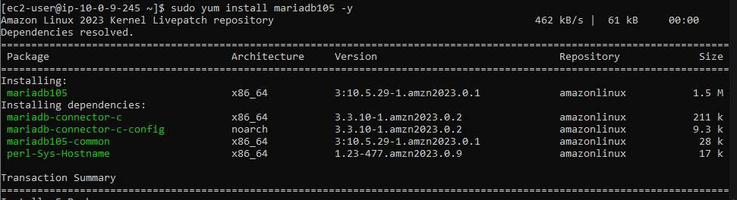

Now connect with RDS DB ec2 instance via endpoint DNS , which you want to manage.
#mysql -h <endpoint of RDS DB > -u admin –p
[-h > hostname which you want to connect , -u > admin , -p > password]
#mysql -h database-1.c6xkgac6c5dq.us-east-1.rds.amazonaws.com -u admin –p
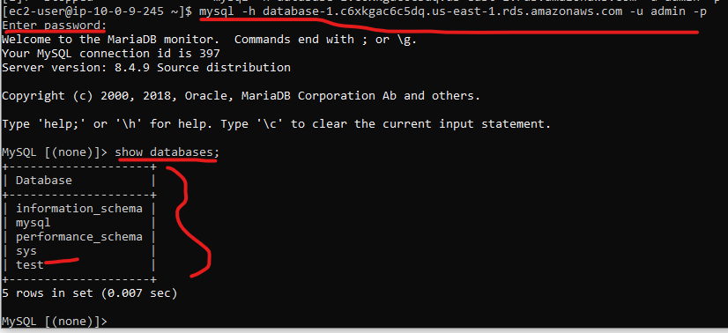
As you can see we are managing RDS database in our Bastion host using MySql client.
But the actual database is still in the AWS RDS private EC2 instance .
Now install the MyQSL server in the Bastion host and manage the database .
Remove the MySQL agent - # sudo yum remove mariadb105 -y
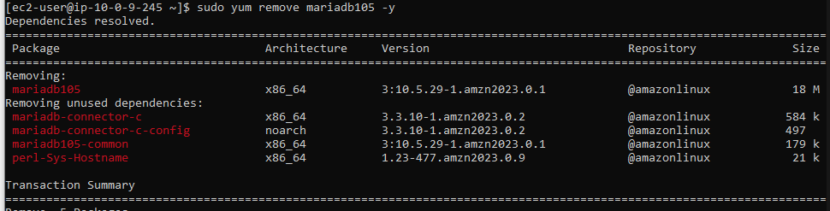
-------- DB on ec2--------------------
#"Installing MySQL server on Amazon Linux 2023"
sudo dnf update
sudo wget https://dev.mysql.com/get/mysql80-community-release-el9-4.noarch.rpm
sudo dnf install mysql80-community-release-el9-4.noarch.rpm
sudo dnf install mysql-community-server
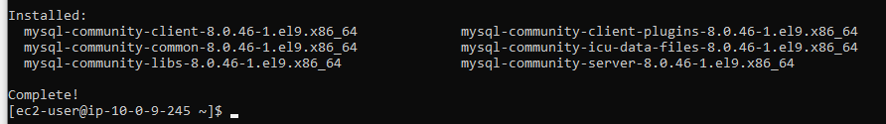

mysql -V

sudo systemctl start mysqld #Starts MySQL service
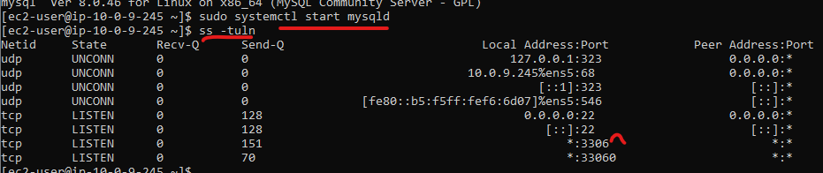
sudo systemctl enable mysqld #Enabled mySQL service to restart on bot
systemctl status mysqld #Check MySQL service running status

#Get Initial Password
sudo grep 'temporary password' /var/log/mysqld.log

(note temp passwd 3F3ot=7b!Ig)
connect MySQL and run below command
mysql -u root -p

give temp password ladter you can run below command for custm password

ALTER USER 'root'@'localhost' IDENTIFIED BY 'Passwd@12';
FLUSH PRIVILEGES;
mysql -u root -p
#create sample data base
CREATE DATABASE IF NOT EXISTS demodb;
SHOW DATABASES;

CREATE TABLE demodb.persons (
PersonID int,
LastName varchar(255),
FirstName varchar(255),
Address varchar(255),
City varchar(255)
);
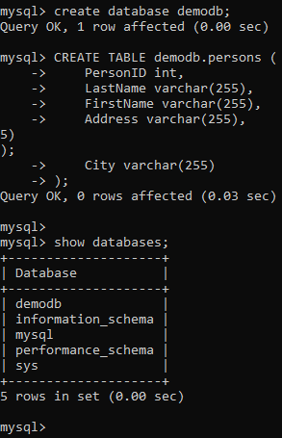

USE DBName;
give demodb

SHOW TABLES;
